## Group Project - Portfolio Optimization of Topix Core 30

Group members: Frankie Li, Howard Lau, Anson Lee, Yolanda Cheng

### 1. Introduction

The Tokyo Stock Price Index (TOPIX) is a highly regarded market index representing all stocks listed on the Tokyo Stock Exchange's (TSE) Prime Market segment. Unlike other indices such as the Nikkei 225, which is price-weighted, TOPIX is free-float-adjusted and market-capitalization-weighted. This makes TOPIX an essential tool for understanding the Japanese stock market's performance across various economic conditions.

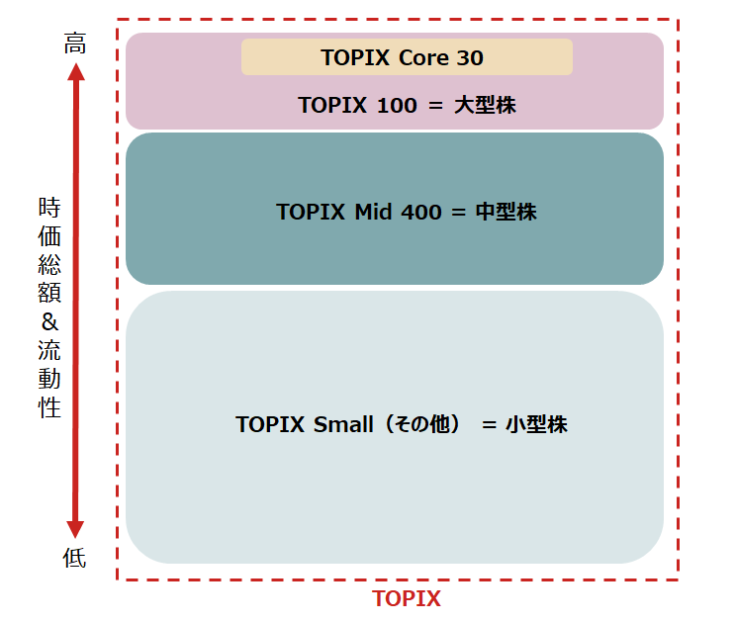TOPIX serves as a benchmark for investors and fund managers, offering a diversified perspective on Japan's stock market. It is divided into several sub-indices, including:

* TOPIX Core30: Tracks the 30 largest and most liquid stocks on the TSE.
* TOPIX Large70: Includes the next largest 70 stocks by market capitalization.
* TOPIX Mid400: Represents mid-cap stocks, providing a broader view of market performance.
* The Core30 comprises some of Japan's most influential companies, such as Toyota, Sony, and SoftBank, making it a focal point for portfolio studies.

The Japanese stock market has recently attracted global attention due to several economic shifts. One key factor is the reversal of Japan's longstanding negative interest rate policy, which began to change early this year. This policy shift reflects growing optimism about Japan’s economic recovery and has encouraged foreign investment. Prominent investors, such as Scott Bessent, former Chief Investment Officer of the Soros Fund, have expressed bullish views on Japan’s market prospects over the next five years. Japan's structural reforms, coupled with its role in emerging technological sectors like robotics and electric vehicles, make its stock market a compelling opportunity for both short- and long-term investors.

The TOPIX Core 30 index offers a balance between simplicity and depth. Its limited number of components (30) makes it manageable for analysis while remaining representative of the larger market dynamics. As a portfolio study target, it combines liquidity, market significance, and analytical tractability.

The components of the TOPIX Core 30 include Japan's largest corporations, which collectively account for a significant portion of the TSE’s market capitalization. These companies span various industries, such as automotive (Toyota), technology (Sony), and finance (Mitsubishi UFJ Financial Group).

List of 30 companies:

1. Seven & I Holdings Co., Ltd.
2. Shin-Etsu Chemical Co., Ltd.
3. A screenshot of a phone

   Description automatically generatedTakeda Pharmaceutical Company Limited
4. Astellas Pharma Inc.
5. Daiichi Sankyo Company, Limited
6. Recruit Holdings Co., Ltd.
7. SMC Corporation
8. Daikin Industries, Ltd.
9. Hitachi, Ltd.
10. Nidec Corporation
11. Sony Group Corporation
12. Keyence Corporation
13. Fanuc Corporation
14. Murata Manufacturing Co., Ltd.
15. Toyota Motor Corporation
16. Honda Motor Co., Ltd.
17. Hoya Corporation
18. Nintendo Co., Ltd.
19. Itochu Corporation
20. Mitsui & Co., Ltd.
21. A blue and red logo

    Description automatically generatedTokyo Electron Limited
22. Mitsubishi Corporation
23. Mitsubishi UFJ Financial Group, Inc.
24. Sumitomo Mitsui Financial Group, Inc.
25. Mizuho Financial Group, Inc.
26. Tokio Marine Holdings, Inc.
27. Nippon Telegraph and Telephone Corporation
28. KDDI Corporation
29. SoftBank Corp.
30. SoftBank Group Corp.

### 2 Stock Component Analysis

The period of interest is defined as October 2022 to October 2024. This window was chosen to capture the impact of the Japanese interest rate reversal and other macroeconomic shifts that have shaped market dynamics. Additionally, historical data from January 2020 to October 2024 was utilized to estimate volatility and return more accurately.

Data for this study was obtained from Yahoo Finance. The dataset includes monthly price data for all TOPIX Core 30 components. Using a broader historical range (2020-2024) helps reduce estimation errors in calculating metrics such as annualized volatility and returns.

Key metrics analyzed for the TOPIX Core 30 components include:

Value at Risk (VaR): Calculated at a 95% confidence interval, VaR quantifies potential losses for individual stocks. The top three stocks with the highest VaR indicate higher risk exposure, while the bottom three represent lower risk.

Top 3:

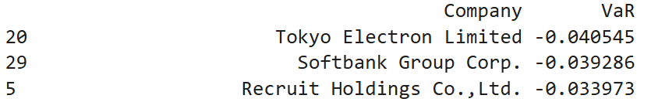

Bottom 3:

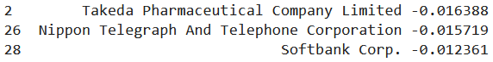

**VaR Histogram**

Top 3 VaR value (Loss more money):

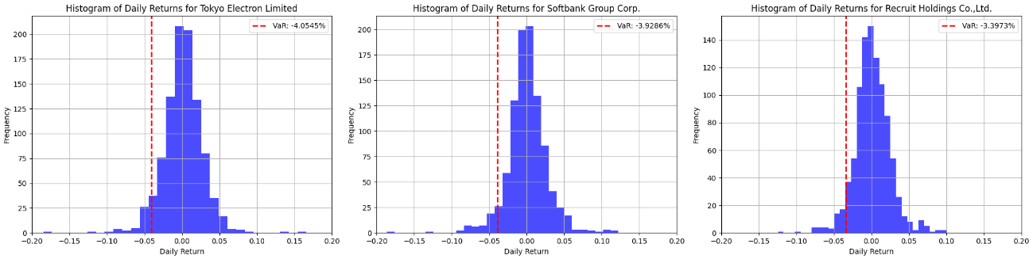

Last 3 VaR value (Loss less money):

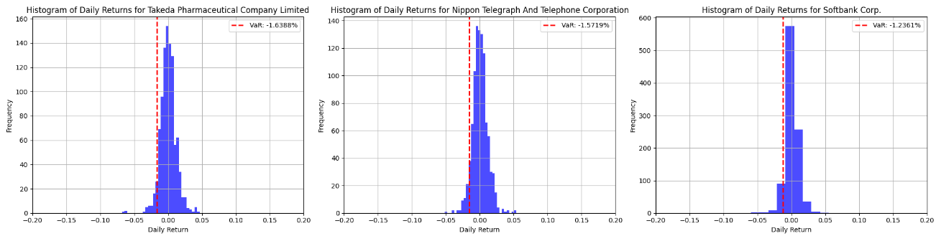

Sharpe Ratio: This metric measures risk-adjusted returns, with higher values indicating more efficient risk-return profiles. For this analysis, the risk-free rate was set at 0.01. This value is chosen from the current 10-year Japanese bond yield.

Highlights from the Analysis:

Top 3 Stocks by Sharpe Ratio: Companies with the highest Sharpe ratios demonstrated strong risk-adjusted returns, making them attractive for portfolio inclusion.

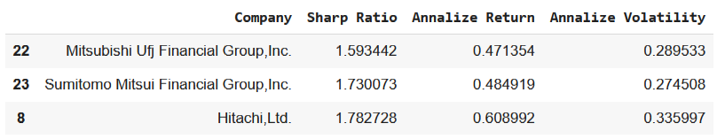

Bottom 3 Stocks by Sharpe Ratio: These stocks underperformed, showing limited efficiency in balancing risk and returns.

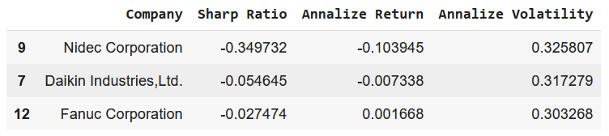

### 3 Portfolio optimization

To enhance investment returns while managing risk, we utilize the Sharpe ratio as a key metric. By constraining the weight of each component to fall between 0.8% and 10%, we aligned the structure closely with the TOPIX Core 30 Index, ensuring a balanced and diversified portfolio. Monthly rebalancing was adopted to mitigate market noise and dynamically adjust to changing market conditions, a critical approach in a volatile economic environment. This strategy reduces the influence of daily fluctuations, emphasizing longer-term trends and allowing for clearer performance comparisons over time. Additionally, monthly rebalancing minimizes the high transactional costs associated with frequent daily trading, such as brokerage fees and slippage, which can diminish returns. By trading less frequently, this approach balances the need to stay aligned with investment objectives while controlling unnecessary expenses, making it an effective method for achieving higher comparative returns.

The effective frontier for the optimized portfolio was generated, showcasing combinations of returns and volatility.

The key results for October 2024 are:

Annualized volatility: 3.239%

Annualized return: 30.87%

This relatively low volatility suggests that the portfolio is well-constructed to withstand market fluctuations, making it attractive for risk-averse investors. Also, the return highlights the effectiveness of the optimization strategy, particularly in a year where economic conditions may have been challenging.

The weight component of the stocks are also found as below:

There are 5 stocks with a maximum weight of 10%. These stocks are Tokio Marine Holdings, Inc., Hitachi, Ltd., Softbank Corp., Sumitomo Mitsui Financial Group Inc. and Seven & I holdings Co, Ltd. There are 20 components with a minimum weight of 0.8% (grouped as Others).

Among the largest weighted stocks, their individual Sharpe ratios are found to be greater than 0.9 which belongs to the top 10 Sharpe ratios stocks.

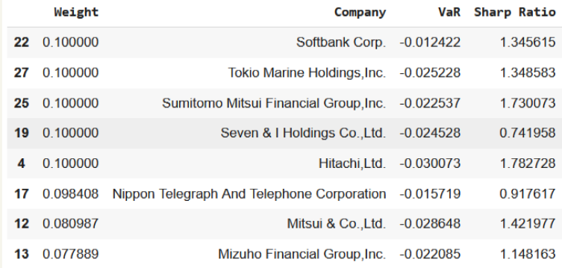

To illustrate the performance of this target portfolio, it was compared with the TOPIX Core 30 Index (1331.T) by calculating the portfolio return with the historical return data. The ticker symbol 1331.T corresponds to the NEXT FUNDS TOPIX-17 BANKS ETF, which tracks the TOPIX-17 Banks Index. Providing a realistic comparison in actual trading.

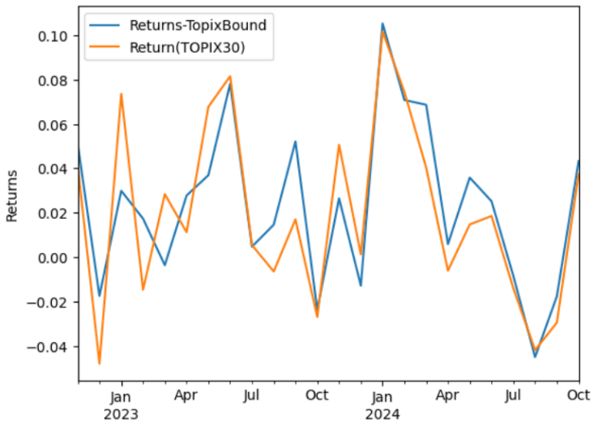

From the left plot, it was shown that:

1. For 2023, the optimized portfolio exhibited lower volatility, indicating a more stable investment experience for portfolio holders.
2. For 2024, it delivered higher returns while maintaining similar volatility levels. This suggests that the optimization strategy effectively capitalizes on market opportunities while managing risk.

The right chart demonstrates that both the optimized portfolio and the portfolio starting in October 2022 outperform 1331.T across their respective periods. The optimized portfolio shows a consistent and steep upward trajectory, reaching an adjusted price of 2895.78 by the end of 2024, compared to 1331.T's 1413.00. Similarly, the portfolio starting in October 2022 also achieves higher growth, with an ending price of 1896.21, highlighting superior performance in both time periods. This outperformance reflects the effectiveness of strategic asset allocation and monthly rebalancing employed in the optimization process.

The cumulative returns of the optimized portfolio and 1331.T were analyzed, revealing that the optimized portfolio achieved a return of 66.96%, outperforming 1331.T, which recorded a return of 57.60%. This 9% difference highlights the effectiveness of the optimized portfolio's strategic asset allocation and robust risk management practices, which contributed to its superior performance.

In summary, the portfolio optimization achieved significant results by maximizing the Sharpe ratio while adhering to specified weight constraints. The analysis reveals a well-rounded portfolio that not only outperforms the benchmark in terms of returns but also exhibits lower volatility, making it a compelling option for investors seeking both growth and stability in their investment endeavors. Continuous monitoring and rebalancing will be crucial to maintaining these advantages as market conditions evolve.

The enhanced returns and reduced risk can be attributed to the negative correlations within the TOPIX 30 constituents. Below is the correlation matrix, showcasing the top 5 highest and lowest correlation pairs among the assets:

The high correlation among stocks like Sumitomo Mitsui Financial Group and Mizuho Financial Group can be attributed to their shared exposure to the same industry (financial services), where market factors impact them similarly. Conversely, the low correlation between stocks such as Nippon Telegraph and Telephone Corporation and Nidec Corporation arises from their presence in distinct sectors with differing market drivers (telecommunications vs. industrial technology). Such negative or low correlations reflect diverse business models and risk factors, which can be leveraged in portfolio optimization to reduce risk while enhancing returns through diversification.

### 4. Risk and Risk Parity minimization

To further investigate the portfolio, we tried to reduce the risk for the portfolio with the following two approaches:

1. Minimize the variance for low-volatility assets  
   This approach focuses on selecting assets that maintain lower volatility, thereby reducing overall portfolio risk. A stable return profile with minimal fluctuations, which is particularly appealing in uncertain market conditions, can be achieved.
2. minimum risk parity  
    This approach ensures that each asset contributes equally to the overall portfolio risk. By equalizing risk contributions, the portfolio can mitigate the impact of any single asset's volatility, fostering a more balanced investment structure.

From the lecture notes:

• Portfolio risk is defined by the portfolio volatility:

$Volatility = (\hat{w})^{T} σ_{p }\hat{w}$

where $\hat{w}$ is the weight vector of the portfolio and $σ_{p}$ is the covariance matrix of the stocks • Risk contribution of an asset i is:

$Risk Contribution of Asset i (RC_{i}) =\frac{Weight of Asset i × Marginal Contribution of Asset i}{Portfolio Volatility}$,

$Marginal Contribution of Asset i = (Covariance Matrix×Weight)_{i}$

By minimizing the square sum difference of the risk contribution to the mean risk contribution, the optimized portfolio ensures that no single asset disproportionately influences portfolio risk.

The Python implementation optimizes weights to equalize risk contribution ($RC_{i}$) across all assets:

def portfolio_vol(weights, cov_matrix):

vol = weights.T @ cov_matrix @ weights

return vol ** 0.5

def risk_parity_objective(weights, cov_matrix):

risk_contribs = risk_contribution(weights, cov_matrix)

mean_risk_contrib = np.mean(risk_contribs)

sum_sq_diff = np.sum(np.square(risk_contribs - mean_risk_contrib))

return sum_sq_diff

def risk_contribution(weights, cov_matrix):

portfolio_vol = np.sqrt(np.dot(weights.T, np.dot(cov_matrix, weights)))

marginal_contrib = np.dot(cov_matrix, weights)

risk_contrib = np.multiply(marginal_contrib, weights) / portfolio_vol

return risk_contrib

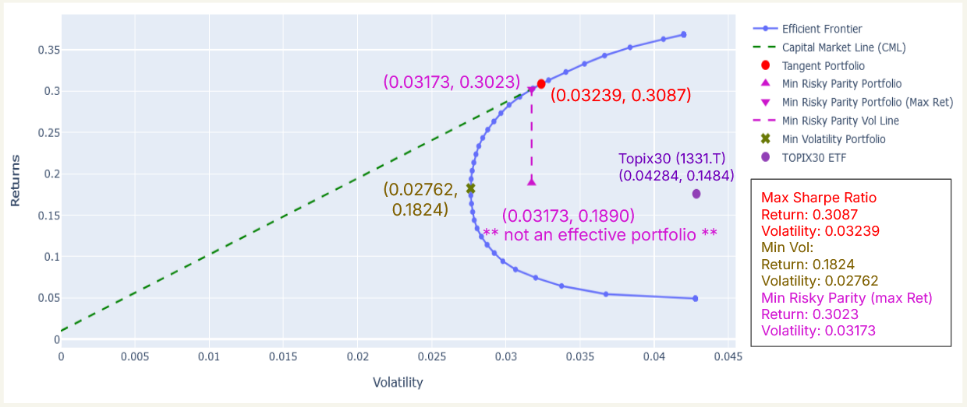The optimization results are plot with the effective frontier as below:

The return and volatility of the minimum volatility portfolio is found to be 18.24% and 2.762% respectively. These two numbers are much lower than those of maximum sharpe ratio, meaning that the portfolio is relatively safe but not able to earn a lot.

The return and volatility of the minimum risk parity portfolio is found to be 18.9% and 3.173% respectively. Compared to the minimum volatility portfolio, the minimum risk parity portfolio volatility is greater, but its return is almost the same. Moreover, the point (upper triangle) is not on the effective frontier. Therefore, this portfolio is not an effective portfolio, exporting a higher risk without a greater return.

Therefore, we further calculate the maximum return portfolio with the same minimum risk parity volatility (lower triangle). The return and volatility of the minimum risk parity portfolio is found to be 30.23% and 3.173% respectively. The return is much greater than that without maximized return. In addition, the volatility and return is slightly less than that of maximum Sharpe ratio, meaning that this portfolio is also a good portfolio of less risk without much affecting the return.

As a reference, the return and volatility of stock 1331.T are also shown in the graph (purple circle). Similar to the minimum risk parity portfolio, it is not an effective portfolio, larger risk but less return.

The monthly returns of these portfolios are plotted in the following two graphs:

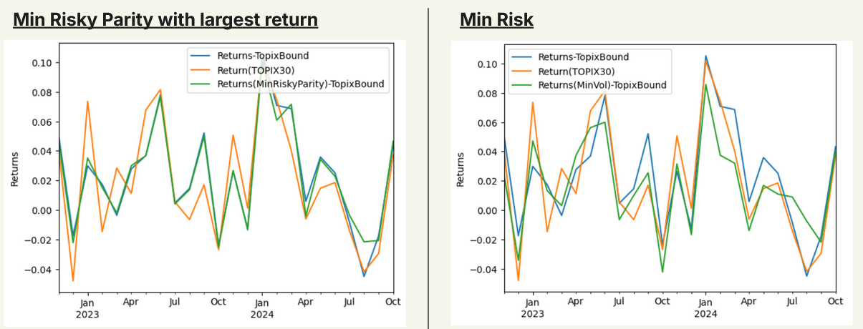

From the left plot, the green line (min risk parity with max return) shows a smaller variation to the blue line (max Sharpe ratio) and the orange line (1331.T). This agrees with the optimized result, with less volatility and with less return.

From the right plot, the green line (min volatility) shows a minimum variation to the blue line (max Sharpe ratio) and the orange line (1331.T). This agrees with the fact that the min volatility should show the least variation.

To further compare the portfolio, we calculated the cumulative returns for these 4 portfolios and the results are shown below:

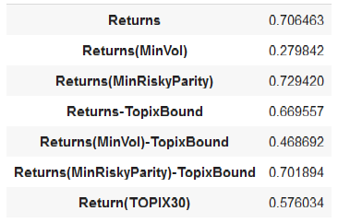

From the table, we can see that maximum cumulative returns is from the min risky parity with max return. It is about 4% greater than that of max Sharpe ratio and 13% greater than 1331.T. This result can be understood by the fact that the small difference between volatilities protected the return from suffering a sudden drop of the market, resulting in a greater cumulative return.

To further look understand the portfolios, the weight distribution are shown in the following pie charts:

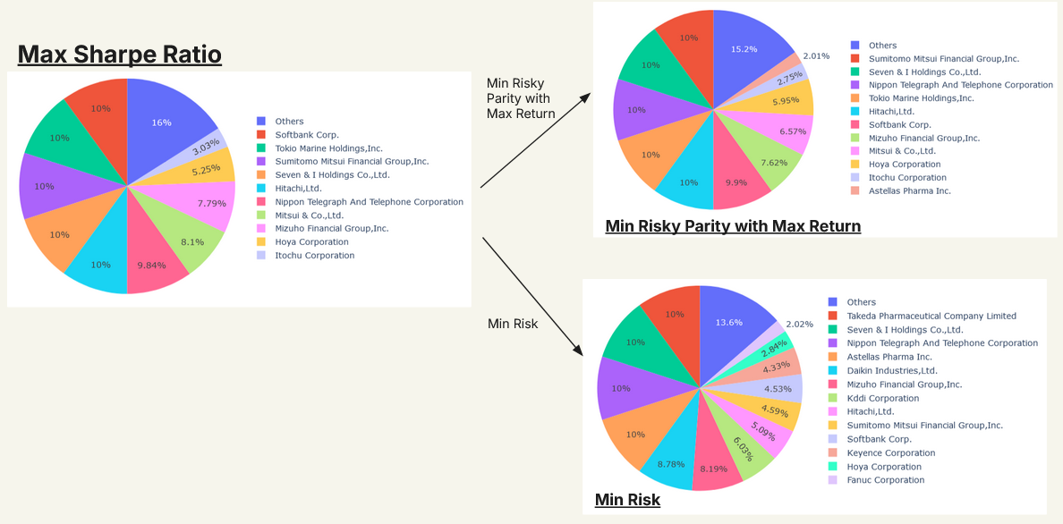

From the pie charts, we can see that the minimum risk parity with maximum return portfolio has similar components of maximum, resulting in similar returns of maximum Sharpe ratio portfolio. The reduction in risk comes from the addition of small component stocks.

In addition, we can see there are many extra components with non-minimum weights in the minimum risk portfolio. This results in a better risk-taking portfolio, but the overall return would be smaller.

In summary, minimizing the volatility can provide a portfolio with the least risk with the least return. The minimum risk with maximum return can provide a portfolio with less risk but larger cumulative return.

### 5. Relaxing Boundary Constraint

To further enhance portfolio returns, we explored the effects of relaxing the weight constraints previously set for our portfolio components. Initially, each stock was limited to a weight between 0.008 and 0.1, mirroring the structure of the TOPIX Core 30 index. By loosening these constraints to allow for weights ranging from 0 to 1, we aimed to identify opportunities for higher returns, even if it meant accepting a potential increase in risk. (Remark: Negative values of lower are not allowed as short selling of the portfolio is allowed).

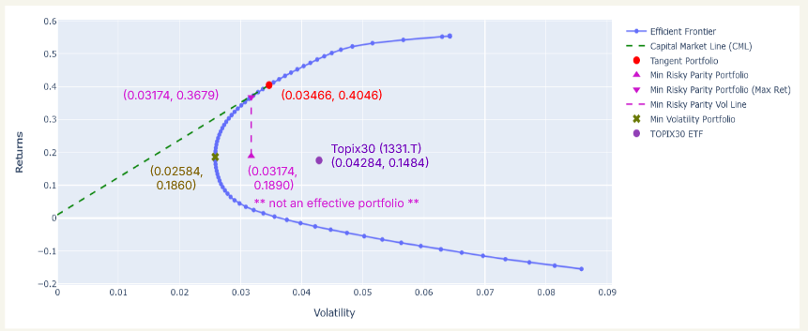Similar to the last section, the effective frontier and the optimized results are shown as below:

We can see that for the maximum Sharpe ratio portfolio, the return is increased from 31% to 40% and its volatility is increased from 3.2% to 3.4%. Clearly, the increase in the risk results in an increase in the return.

For the minimum volatility portfolio, the return is slightly increased from 18.2% to 18.6% while the volatility is slightly decreased from 2.76% to 2.56. This results in a more confident portfolio with a slightly larger return.

For the minimum risk parity portfolio with the largest return, the volatility almost remains unchanged. It is due to the ineffective portfolio results. The portfolio return is increased from 30% to 36%. Under the same volatility, the relaxation of boundary value provides a portfolio with similar risk but a greater return.

The monthly return of the portfolios (except minimum volatility) are shown in the following plot.

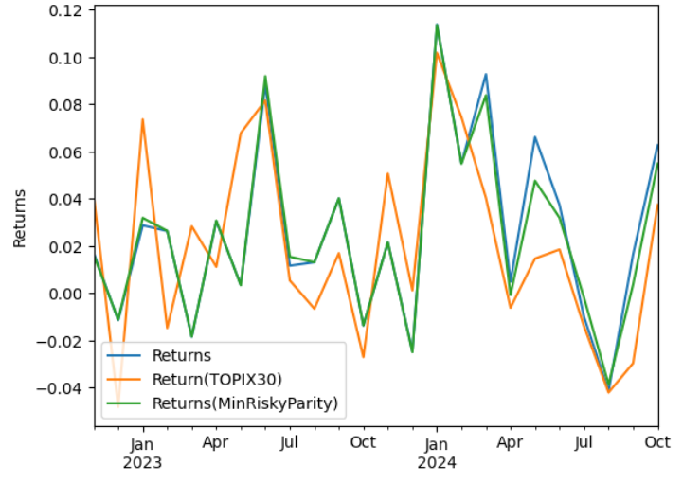

From the plot, we can see that the tangent portfolio (blue line) and the min risk parity portfolio (green line) can beat the returns of TOPIX30 (orange line). Both tangent portfolio (blue) and min volatility portfolio (green) have smaller volatility than TOPIX30 (orange).

For the cumulative return, the result is shown in the following table:



From the table, the behaviors of the three portfolios are similar to those with TOPIX boundary values. In addition, both minimum risk parity portfolios with maximum return have greater values of cumulative return 70% and 73%. The portfolio of minimum risk parity, maximum return and relaxed boundary values has the largest cumulative return, 73%.

For the weight distribution, the distribution of the maximum Sharpe ratio portfolio is shown below.

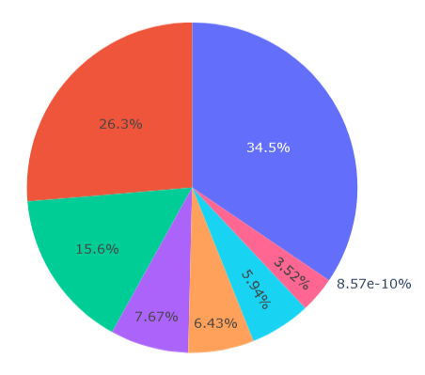

Unlike the result of TOPIX bound, without the lower boundary value, the weights are only contributed to 7 stocks only. This would increase the portfolio, but the volatility would also increase.

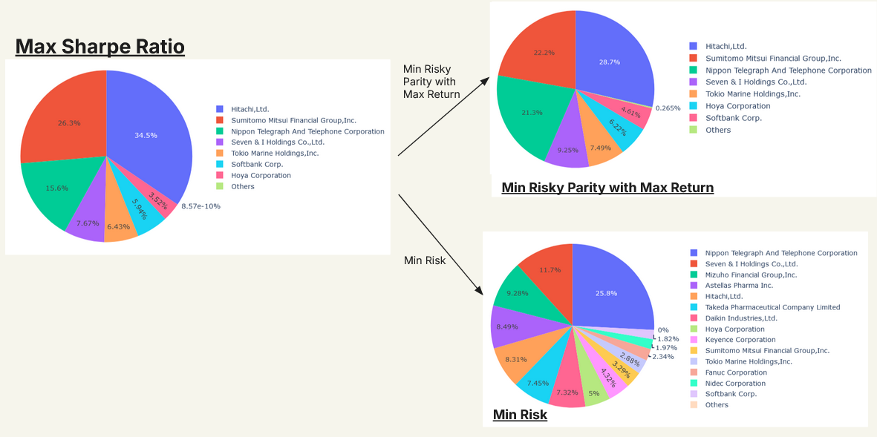

In addition, the behaviors of the weights in the two risk minimizing cases are similar to that with the TOPIX boundary. By adding extra stocks, the volatility can be reduced but the return would also increase. To summarize, relaxing weight constraints have proven to be a beneficial strategy for optimizing portfolio returns. The findings confirm that a more flexible approach can yield portfolios that not only enhance returns but also offer improved risk management. The Minimum Risk Parity with Maximum Return Portfolio stands out as an effective option, providing a favorable balance of return and volatility.

Overall, these insights reinforce the importance of dynamic portfolio management strategies in adapting to changing market conditions and investor goals. Future considerations may include further analysis of the underlying assets to ensure continued alignment with market trends and risk assessments.

### 6. Inducing Short Selling for Increased Returns

#### Optimization results: Long-Short Portfolio with Different Bounds vs Long-Only

With a narrow bound (-0.1,0.1) in long-short, most returns beat long-only by having less volatility. The maximum Sharpe ratios are about the same but the long-short one has less volatility. However, the long-only portfolio becomes dominant if the investor requests a higher return.

When the bound for long-short widens, i.e. (-1,1), the efficient frontier completely beats long-only in terms of return, volatility, and Sharpe ratio. The graph shows better risk management in the long-short than long-only.

#### Cumulative Returns Comparison in Long-Short and Long-Only

Although the result from the efficient frontiers has shown that the long-short is a better strategy, this is a different case considering the cumulative return based on the historical returns.

We calculated the weights each month by cumulating the past returns and minimizing the volatility, then we have the returns for each month. By October 2024, the cumulative returns of different techniques/portfolios are shown in the table using the cumulative product formula.

The long-only portfolio has the best return among all, including different short-leverage values. This may indicate that the long-short strategy is limited to specific market conditions and other possible factors.

#### Long-Short Leverage Advantage and Drawback

The main difference between long-only and long-short is that long-short has a constraint for gross exposure limit and an ability to short. Gross exposure limit limits the sum value of weights of assets and the value of weight to short is negative, which brings greater flexibility and more effective risk management to the long-short strategy. The ability to short can be a cushion to protect the capital from loss. Generally, a long-short strategy is conservative, especially when a tighter bound is set, limiting the ability to long and short. Wider bounds may allow for greater flexibility and the ability to capitalize on market downturns, which can enhance returns during volatile or bearish periods. However, they can also introduce more risk and lead to lower cumulative returns if the market is predominantly bullish.

#### A graph with blue and green lines Description automatically generatedA graph of a price Description automatically generated with medium confidenceRelative Strength Index and Strong Bullish Market when Long Short

The overall market environment can significantly impact on the performance of a portfolio. We suspect that past market conditions were disadvantageous to the long-short strategy compared to the long-only strategy. The Relative Strength Index of historical data, shown in the first graph above, indicates a strong bull market starting in September 2023, with the index exceeding 70. Aligning with the second plot above, the volatility of returns for long-short strategies (-1, 1) and (-0.4, 1) increased significantly from that month compared to the long-only strategy (0, 1). In certain periods, the returns of long-short strategies outperformed long-only strategies. However, as noted in Section 5.2, long-only strategies achieved the best cumulative returns overall. This suggests that while the long-short strategy can generate higher returns, its short positions may outweigh the gains and detract from overall performance. In such market conditions, the more aggressive long-only strategy tends to perform better.

### 7. Summary of Results

The analysis underscores the effectiveness of different portfolio optimization techniques, highlighting the trade-offs between return, risk, and complexity:

Constrained Portfolios:

Applying TOPIX boundary conditions (weights between 0.008 and 0.1), these portfolios achieved a cumulative return of 66.96% with a volatility of 3.239%. Top-performing stocks included Toyota, Nippon Telegraph, and Sony, reflecting a balanced yet targeted allocation.

Relaxed Weight Portfolios:

By relaxing weight constraints (0 to 1), these portfolios delivered a higher cumulative return of 70.6%, with a slightly increased volatility of 3.466%. Leading contributors included Hitachi, Sumitomo Mitsui Financial Group, and Nippon Telegraph, showcasing the potential of broader allocation flexibility.

Minimum Risk and Maximum Return Portfolios:

Optimizing for minimum risk parity and maximum returns yielded cumulative returns of 72.9% for weights between 0 and 1 and 70.2% for weights constrained between 0.008 and 0.1. These portfolios exhibited lower volatilities at 3.174%, outperforming the constrained portfolios in both risk and return metrics.

Short Selling Portfolios:

Incorporating short selling provided the highest performance on the efficient frontier. Portfolios with weights ranging from -0.4 to 1 achieved a cumulative return of 67%, slightly lower than long-only strategies. This decrease can be attributed to market history and relative strength index (RSI) trends. Notable long positions included Tokyo Electron and Daiichi Sankyo, while top short positions featured Nippon Steel and Mitsubishi Chemical.

These results highlight how relaxing constraints and leveraging short selling can enhance returns but may introduce additional complexity and risk, necessitating careful implementation and monitoring.

### 8. Further Study

Future directions for portfolio optimization include:

Daily Rebalancing:

Shifting from monthly to daily rebalancing to capture short-term trends and maintain optimal allocations dynamically.

Advanced Metrics:

Incorporating advanced metrics such as Conditional Value at Risk (CVaR), skewness, and kurtosis for a more detailed analysis of portfolio performance and risk.

Multi-Asset Portfolios:

Enhancing diversification and stability by including additional asset classes like bonds or international equities.

Simulation and Backtesting:

Employing Monte Carlo simulations to evaluate portfolio performance under various market conditions, providing robust insights into potential risks and returns.

A robust portfolio optimization strategy starts with careful stock selection, focusing on fewer than 30 stocks for manageability and focus. Selection should prioritize liquidity, market capitalization, historical performance, and sector diversification.

Daily rebalancing dynamically adjusts the portfolio to reflect price changes, while techniques like Mean-Variance Optimization (MVO) and Risk Parity allocate capital effectively.

Key metrics, including Beta, CVaR, skewness, kurtosis, and drawdown analysis, offer a comprehensive evaluation of portfolio effectiveness. Monte Carlo backtesting further validates the strategy by simulating performance under various scenarios.

Finally, incorporating bonds or other asset classes into multi-asset portfolios improves diversification and risk management, creating a more resilient and adaptive portfolio that balances risk and return effectively.

### 9. References

1. Lau, F. (2024). Financial Risk Analysis and Portfolio Optimisation - Lecture 5: Portfolio Optimisation. [Lecture Notes]. Postgraduate Diploma in Financial Analytics and Algo Trading, HKU SPACE.
2. SpringerLink (2023). An Investigation of the Volatility Adjustment. [online] Available at: https://link.springer.com/article/10.1007/s10203-023-00416-y [Accessed 3 Dec. 2024].
3. Bookdown (n.d.). Understanding Portfolio Volatility Risk. [online] Available at: https://bookdown.org/compfinezbook/introcompfinr/understanding-portfolio-volatility-risk-decompositions.html [Accessed 3 Dec. 2024].
4. Python Notebook Outputs. Weight optimization and portfolio returns using scipy.optimize.
5. Yahoo Finance (n.d.). Historical Stock Prices for TOPIX Core30 Components.
6. Visualization Libraries. matplotlib for weight distributions and efficient frontier plots.
7. Capinski, M. and Zastawniak, T. (2003). Mathematics for Finance: An Introduction to Financial Engineering. Springer.
8. Hill, R.A. (2012). Corporate Valuation and Takeover. Palgrave Macmillan.
9. Kachapova, F. (2015). Mathematical Models in Portfolio Analysis. Springer.
10. Hill, R.A. (2013). Portfolio Theory & Financial Analyses. Palgrave Macmillan.